What’s so Funny? How to Get into Stand-Up Comedy

C.T. Corum

[c.t.corum@gmail.com](mailto:c.t.corum@gmail.com)

You can feel the sweat begin to form on your brow when you step onto the tiny podium. As you approach the microphone, you feel the intense heat of the bright lights that are shinning down on you. In the audience, all you can see are darkened silhouettes of people who are waiting for someone to ease their stressful lives. You clear your voice.

What do you say?

This is a scenario that faces all professional comedians, no matter the experience level. Audiences may range from a handful of people to thousands of individuals, but the overall process and principles of standup comedy remain the same. The goal is always to make the audience laugh, but how do comedians accomplish this?

But first, how can students at Metropolitan State get involved in standup comedy?

Ryan Patchin is a student at Metro State, who plans to graduate with a major in creative writing. Patchin has done six open mic routines, and he offers his advice for students who are looking to become a stand-up comic.

“You need that exposure,” Patchin said. “You need to get out there as much as you can to get as much exposure as possible.”

This is not only the most important step to becoming a well-known comedian, it is also one of the hardest. Commitment and dedication are required for someone who is serious about becoming a comic professionally. Agents are known to come to open mics to see if there is anyone talented performing. If they see someone they like, then chances are this comedian will be able to act as a “middle” (buzzword for one of the opening acts) at a show. As the comedian builds popularity, he or she can move up to become a feature and then a headline.

“You want to be discovered as much as people want to discover you,” said Patchin.

Knowing your audience is another piece of advice that Patchin gives. Jokes need to be tailored to the audience that you are performing to. Without this familiarity, many comedians will fail by either presenting jokes that are too offensive or using jargon that the audience doesn’t understand.

[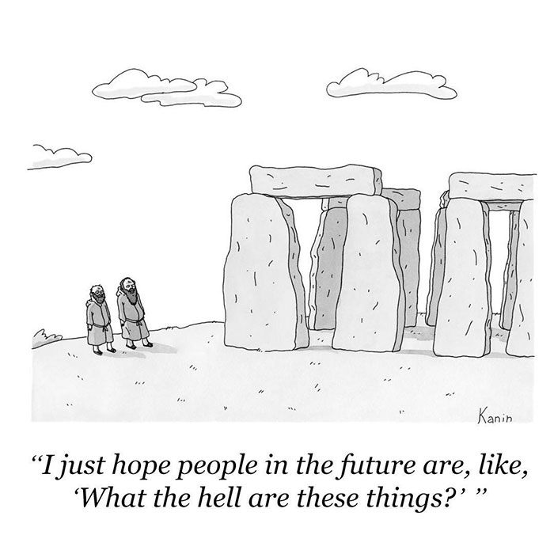](https://www.google.com/url?sa=i&rct=j&q=&esrc=s&source=images&cd=&cad=rja&uact=8&ved=0ahUKEwjQzpuRpczSAhVK74MKHZ7SCz8QjRwIBw&url=http://www.boredpanda.com/the-new-yorker-cartoons/&bvm=bv.149093890,d.amc&psig=AFQjCNHtUAZkqxVafH-5C5ecki8yonpntg&ust=1489246190886698) 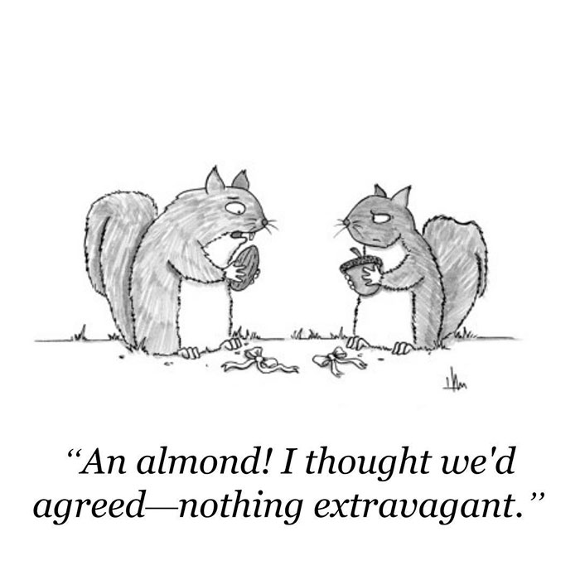

Source: The New Yorker

Source: The New Yorker

Funny things happen around us all the time. Everyday life can be hilarious when looked at from a different perspective. This is why Patchin also recommends that you write things down that make you laugh. Patchin uses his phone and makes notes whenever he comes across something unusual or entertaining.

But how do comedians decide what material is funny?

According to Scott Weems, a cognitive scientist and author of the book “Ha! The Science of When We Laugh and Why,” one of the most important components of humor is surprise. To illustrate this point, let’s look at an example that Weems uses:

“Two hunters from New Jersey are out in the woods when one of them collapses. He doesn’t seem to be breathing and his eyes are glazed over. The other guy whips out his phone and calls the emergency service. He gasps, ‘I think my friend is dead! What should I do?’ The operator says, ‘Calm down. I can help. First, make sure he’s dead.’ There is a silence, then a shot is heard. Back on the phone, the guy says, ‘Okay, now what?’”

When writing a joke, surprise is one of the most important ingredients. In this example, it was the surprise that, rather than taking his friends pulse, the hunter misunderstands and instead shoots his friend.

A standup comedian should write down his or her material, practice it every night and modify it to fit the audience. These are the basic tools of a comedian, and these are tools that anyone can use. For Metro State students who are looking to become standup comedians, all it takes is commitment, passion and an ability to look at the world in a different perspective.

“Be repetitive, hone [your skills], and get better every day,” said Patchin.

In the end, being a standup comedian is easy. All you have to do is make the audience laugh.